CHAPTER 4
RESULTS AND DISCUSSION

Description of Prototype
The developers created the Tap, Task, Done prototype to demonstrate how clients and service providers can arrange and manage one-time service requests through a website. The preliminary design organized the system around the main user activities, including posting a task, finding a service provider, communicating about a request, and following its progress. These requirements guided the layout of the dashboard and the placement of its navigation links. The prototype allows the developers to examine whether users can move between these features and complete representative tasks. The developers evaluate its functionality and usability by checking whether the controls produce the expected results and observing where users encounter difficulty. The findings from these checks and user feedback will guide revisions to the layout, instructions, and task workflow.
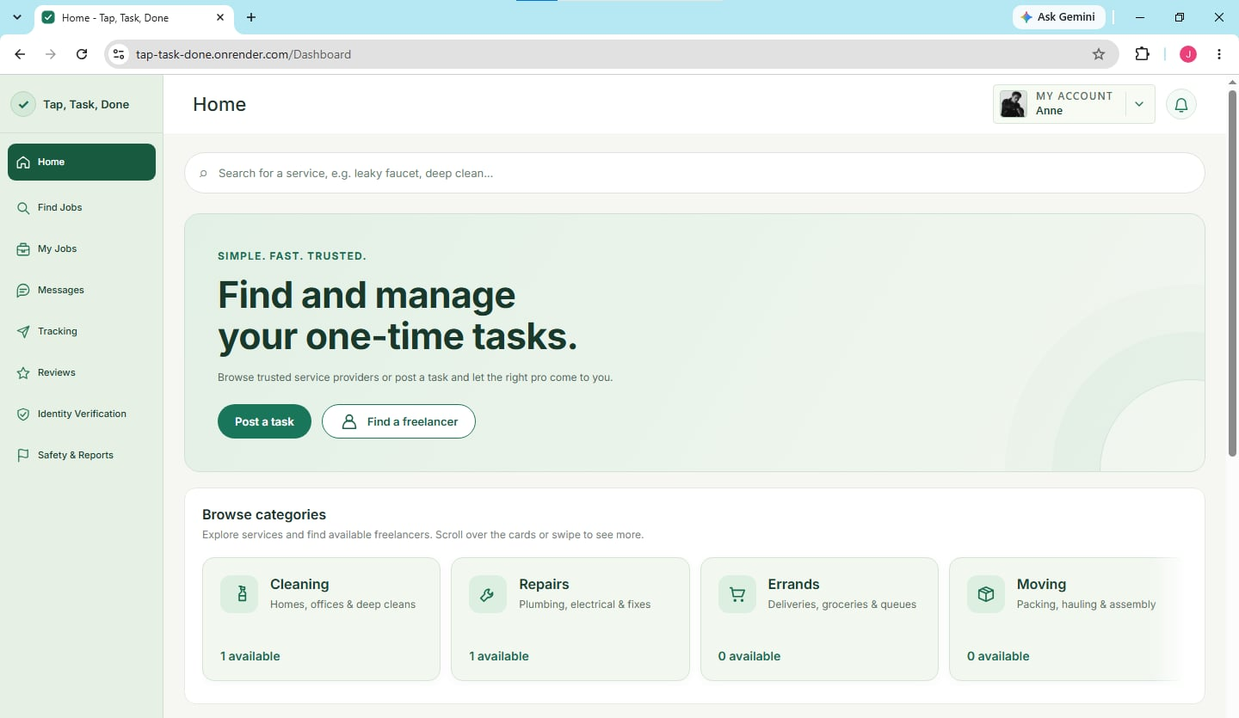
Figure X. Tap, Task, Done Web Module
Figure X presents the initial design and prototype of the Tap, Task, Done web-based application. The Home dashboard places the service search bar and the Post a task and Find a freelancer buttons above category cards for Cleaning, Repairs, Errands, and Moving. Clients can begin a service request from the dashboard or browse providers by category. Service providers can use Find Jobs to browse available requests and My Jobs to view their assigned work. The sidebar also provides access to Messages, Tracking, and Reviews, which users can use to coordinate and follow up on service activities. By observing how users navigate from the dashboard to these sections, the developers can identify labels or controls that need clarification.

Implementation Plan
The developers will prepare the Tap, Task, Done website for operational use by configuring the application and installing the software required to run it. They will set up the web server environment and configure the application’s connection to the MySQL database. Before release, the developers will verify that the website can save and retrieve account, booking, and task records. They will then check that the major modules work together by following a sample request from posting or booking through completion. System testing will cover response times during common operations, the consistency of task updates, and access restrictions for each user role. The developers will prepare instructions for clients, service providers, and administrators and address defects that prevent them from completing their tasks. The website will be released for initial use after the developers verify that the required workflows operate as intended.

Implementation Tasks

System Configuration and Installation
- Package the ASP.NET Core web application using the project’s Docker configuration and install it in the designated hosting environment.
- Configure the MySQL database connection, server settings, and network access required to run the website over HTTPS.

Integration and Connectivity
- Verify that booking, messaging, and tracking work together when a service request is assigned to a provider.
- Check that the website can save and retrieve records from MySQL and that the client and provider views reflect the same booking and task status.

Testing and Quality Assurance
- Run the website test scripts with client, service provider, and administrator accounts. Record any defects and repeat the affected tests after corrections.
- Check page response times, the consistency of saved updates, access restrictions, and how easily users can complete common tasks in a browser.

User Training
- Demonstrate how clients can post requests and find service providers, and how providers can find jobs, respond to bookings, and report task progress.
- Orient administrators on account management, identity verification, and the review of safety reports related to service requests.

Resources Needed

Hardware
- Desktop computers or laptops for developing, accessing, and testing the website and its administrative pages.
- Network equipment, such as a router or wireless access point, and a stable internet connection for website access and connectivity testing.

Software
- Google Chrome for accessing the website and checking its layout, navigation, and forms.
- Visual Studio Code for editing the application source files.
- The .NET 8 SDK for building the application and the ASP.NET Core 8 runtime with Kestrel for running and serving the website.
- MySQL for storing application records and Entity Framework Core for accessing those records from the website.
- Docker for building and running the deployment package defined in the project repository.

Personnel
- The developers will configure and deploy the website, correct implementation issues, and maintain the application.
- Testing personnel will execute and document the test cases. Administrators and selected clients and service providers will participate in orientation and evaluate the workflows assigned to their roles.

